**Article 6. Commercial Zoning Districts: CG, CR**

**6.1 PURPOSE**

**6.2 USES**

**6.3 DIMENSIONAL AND DESIGN STANDARDS**

**6.4 OPEN SPACE REQUIREMENTS**

**6.5 ON-SITE PEDESTRIAN CONNECTIVITY REQUIREMENTS**

**6.6 SUPPLEMENTAL DEVELOPMENT STANDARDS**

**6.1 PURPOSE**

**A. CG General Commercial Zoning District**

The CG General Commercial Zoning District is intended to accommodate areas of general commercial development in the City, typically located at key intersections or organized along arterial streets. Commercial areas within the CG Zoning District accommodate automobile access and the standards for the zoning district acknowledge this auto-orientation while encouraging improvement of the pedestrian environment and accommodation of alternate modal choices within the zoning district.

**B. CR Regional Commercial Zoning District**

The CR Regional Commercial Zoning District is intended for areas of large-scale and/or regionally significant commercial uses. Such uses may constitute a coordinated cluster of commercial uses or a single large-scale commercial use of regional significance. The zoning district regulations ensure that proper controls are in place to create compatibility with neighboring uses and create safe circulation patterns.

**6.2 USES**

Article 15 lists permitted, temporary, and accessory uses for the Commercial Zoning Districts. Use definitions are found in Article 15. Prescribed conditions applicable to certain principal uses, temporary uses, and accessory uses are also found in Article 15.

**6.3 DIMENSIONAL AND DESIGN STANDARDS**

**A. General**

**1.** The tables below include the dimensional and design standards for the Commercial Zoning Districts. Standards within the tables below may contain specific regulations organized by frontage type (Section 3.5).

**2.** Where this Ordinance refers to frontages in general, transit station, off-street public path, public park shall not be considered a frontage within the Commercial Zoning Districts.

**3.** In the tables below, where a cell contains a standard or a “✓” the standard is applicable. Where a cell is blank and shaded, the standard does not apply.

**4.** Within Commercial Zoning Districts, the following shall apply to multi-family attached residential developments:

**a.** If a minimum 25’ Class B landscape yard, measured from the future right-of-way line, abuts and runs parallel to an arterial street, the portion of the arterial street abutting this landscape yard shall not be considered a frontage for the standards of this article. The portion of the arterial street abutting this landscape yard shall still be considered a frontage for the standards of the remainder of this Ordinance. No parking lots shall be located between these landscape yards and permitted uses.

**B. Lot**

Lot standards govern the basic dimensions of lots, including but not limited to minimum area, width, and coverage as applicable. These standards are intended to provide a rational basis for the division, organization, and development of land within the City of Charlotte.

| **Table 6-1: Commercial Zoning Districts Lot Standards1** | | | |
| --- | --- | --- | --- |
|  | | **CG** | **CR** |
| **A** | **Minimum Lot Width** (feet) | 50 | 50 |
| **1** | Lot Standards do not apply to individual sublots but do apply to the parcel on which the sublot(s) is located. | | |

**C. Building Siting**

Building siting standards govern the placement of buildings on lots, and are intended to ensure that development maintains compatibility with its surrounding context and the intent of the applicable zoning district.

| **Table 6-2: Commercial Zoning Districts Building Siting Standards** | | | |
| --- | --- | --- | --- |
|  | | **CG** | **CR** |
| **A** | **Frontage Setback Line** (from future back of curb) (feet) **1, 2, 3** | | |
|  | Uptown Signature | 24 | 24 |
| Main Street | 24 | 24 |
| Linear Park | 36 | 36 |
| 4-5 Lane Avenue/Boulevard | 36 | 36 |
| 6 or more Lane Avenue/Boulevard | 40 | 40 |
| 2-3 Lane Avenue | 36 | 36 |
| Transit Station, Off-Street Public Path, Public Park **4** | 20 | 20 |
| Uptown Primary | 20 | 20 |
| Other - Primary | 36 | 36 |
| Uptown Secondary | 16 | 16 |
| Secondary | 36 | 36 |
| Parkway (Measured from ROW) | 20 | 20 |
| Limited Access (Measured from ROW) | 20 | 20 |
| **B** | **Frontage Build-To Zone (BTZ)** (from frontage setback line) (feet) **5, 6** | | |
|  | Main Street | 0-20 | 0-20 |
| 4-5 Lane Avenue/Boulevard |  |  |
| 6 or more Lane Avenue/Boulevard |  |  |
| 2-3 Lane Avenue |  |  |
| Transit Station, Off-Street Public Path, Public Park |  |  |
| Other - Primary |  |  |
| Secondary |  |  |
| Parkway |  |  |
| Limited Access |  |  |
| **C** | **Minimum BTZ Build-To Percentage for Structure** (%) | | |
|  | Main Street | 80 | 80 |
| 4-5 Lane Avenue/Boulevard |  |  |
| 6 or more Lane Avenue/Boulevard |  |  |
| 2-3 Lane Avenue |  |  |
| Transit Station, Off-Street Public Path, Public Park |  |  |
| Other - Primary |  |  |
| Secondary |  |  |
| Parkway |  |  |
| Limited Access |  |  |
| **D** | **Minimum Side Setback** (feet) | 10 | 10 |
| **E** | **Minimum Rear Setback** (feet) | 20 | 20 |

|  |  |
| --- | --- |
| **1** | On local and collector streets in the CG and CR Zoning Districts, measured from the curb location of Office/Commercial Narrow Local Street Cross Section in CLDSM or the existing back of curb, whichever is farthest from the centerline. If SSI standards require the relocation of the back of curb or the back of curb is voluntarily relocated, that shall be considered the existing back of curb location. |
| **2** | In no case shall any building entry be located closer than six feet to an existing or proposed off-street public path or shared use path. |
| **3** | In the CG and CR Zoning Districts, if no parking or maneuvering is located between a building and the frontage, then the frontage setback line may be reduced to match the standard required for the CAC-1 Zoning District. |
| **4** | For the transit station, off-street public path, public park frontage, shall be measured from a property line or right-of-way line. If there is an easement in place for any frontage, then the measurement shall be taken from such easement. For any frontage abutting a reservation for a future frontage, the frontage setback line shall be measured from the edge of the reservation area. |
| **5** | When an existing Charlotte Water easement, other utility easement, or overhead utility clearance requirement conflicts with the build-to zone requirement, a build-to line shall be established at the edge of the easement or the edge of the overhead utility clearance requirement closest to the build-to zone. A build-to zone shall not be required along frontages which abut a man-made or natural physical feature 35 feet in width or greater such as, but not limited to, a railroad line, rapid transit line, gas pipeline, SWIM buffer, or a buffer related to post-construction stormwater requirements. This does not include any stormwater control measure as required by this Ordinance. |
| **6** | Where a lot has more than two frontages that require a build-to zone, the build-to zone shall be increased by 100% for those frontages that exceed two. Such an increase should be applied to those frontages that are lowest in the established hierarchy of frontages (Section 3.5.D). |

**D. Building Height**

Building height standards govern the maximum heights of buildings as applicable, and are intended to provide flexibility while maintaining appropriate transitions to adjacent areas.

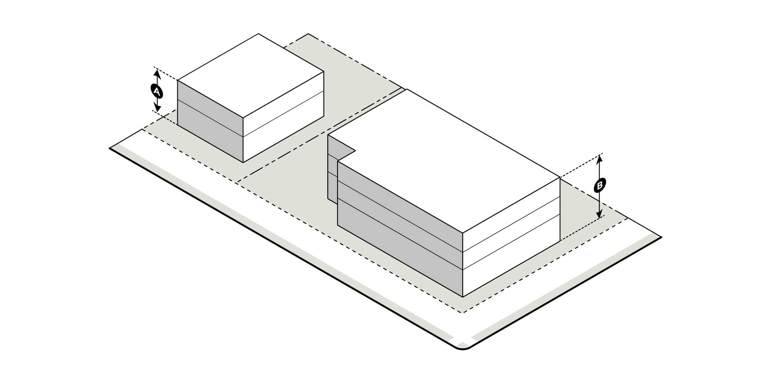

| **Table 6-3: Commercial Zoning Districts Building Height Standards** | | | |
| --- | --- | --- | --- |
|  | | **CG** | **CR** |
| **A** | **Maximum Building Height** (feet) **1** | 50 | 50 |
| **B** | **Maximum Height with Bonus** (feet) (Section 16.3) **1, 2** | 65 | 65 |

|  |  |
| --- | --- |
| 1  2 | The height and location of structures may be restricted by the limitations set forth in the Code of Federal Regulations (CFR) Title 14 Part 77: Safe, Efficient Use, and Preservation of the Navigable Airspace.  A notice of proposed construction FAA Form 7460-1 must be filed with the FAA for construction or alteration that impacts any of the imaginary surfaces as defined in 14 CFR Part 77, or is more than 200 feet in height above the ground at its site at least 45 days prior to construction. The Aviation Department Planning Division may serve as a point of contact for information regarding building notification requirements and obstruction evaluation  The maximum building height of any structure within 200 feet from the lot line of residential uses or vacant land in a Neighborhood 1 Place Type is limited as follows: Portions of a structure within the first 100 feet are limited to a maximum height of 50 feet. Portions of a structure located between 100 and 200 feet are limited to a maximum height of 65 feet. Beyond 200 feet, the building height is limited by the maximum height of the zoning district. Building heights for all portions of a structure shall be measured from the average grade established for the whole building. This limitation does not apply to public parks of three acres or greater within a Neighborhood 1 Place Type, nor to an area of two or fewer parcels totaling no more than three acres within a Neighborhood 1 Place Type. |

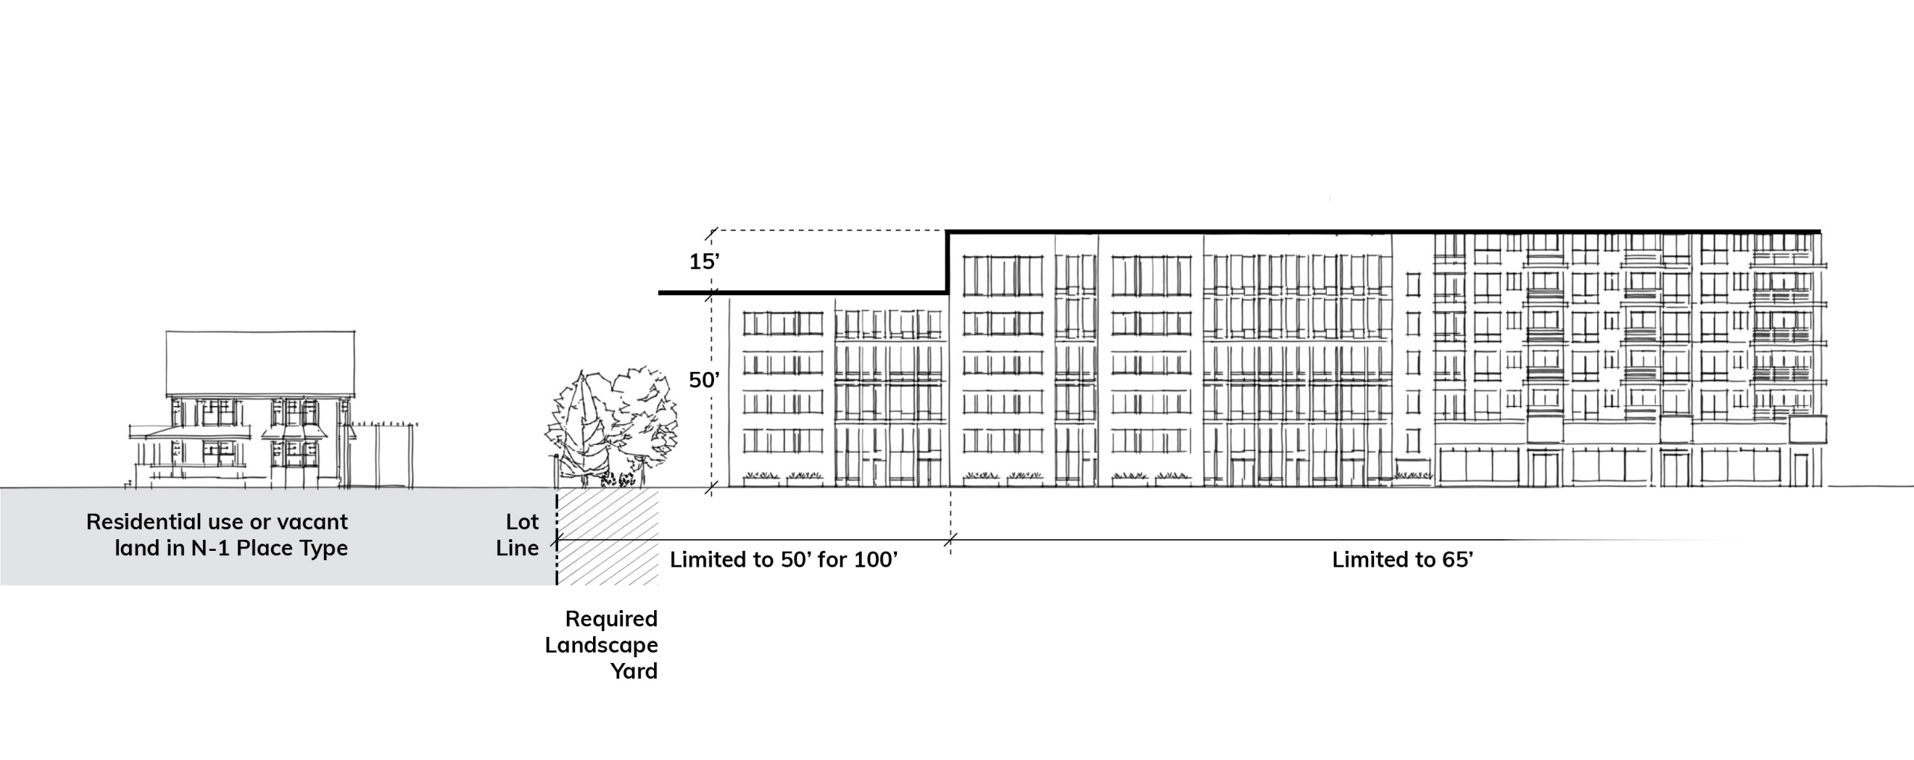

**E. Building Articulation**

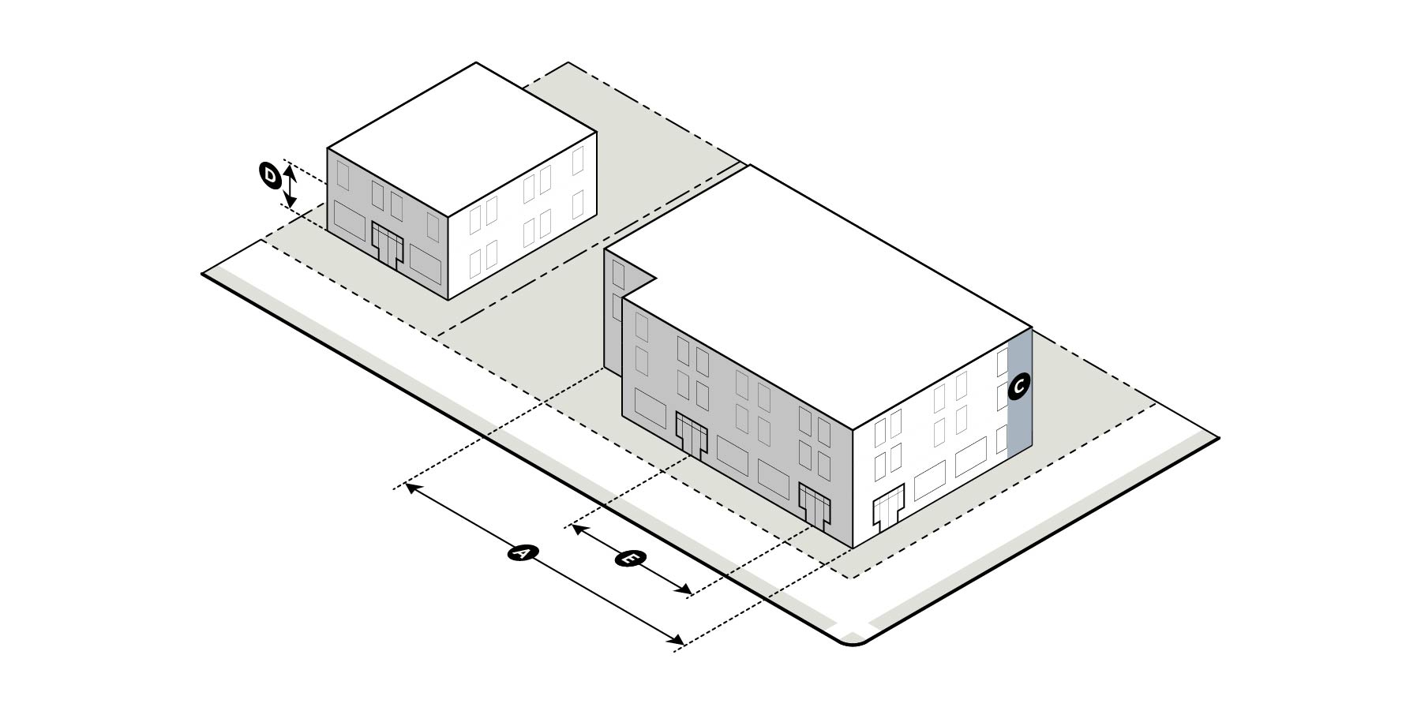Building articulation standards govern the dimensions of building facade elements and entry features and are intended to facilitate the enhancement of a pedestrian-oriented environment.

| **Table 6-4: Commercial Zoning Districts Building Articulation Standards** | | | |
| --- | --- | --- | --- |
|  | | **CG** | **CR** |
| **A** | **Minimum Building Length as a Percentage of Lot Width Along Frontage** (measured at frontage setback line) (%) **1, 5, 6** | | |
|  | Main Street | 60 | 60 |
| 4-5 Lane Avenue/Boulevard |  |  |
| 6 or more Lane Avenue/Boulevard |  |  |
| 2-3 Lane Avenue |  |  |
| Transit Station, Off-Street Public Path, Public Park |  |  |
| Other - Primary |  |  |
| Secondary |  |  |
| Parkway |  |  |
| Limited Access |  |  |
| **B** | **Maximum Building Length Along a Frontage** (feet) **2** | 500 | 650 |
| **C** | **Maximum Blank Wall Area - (Ground floor and upper floor; Horizontal or Vertical; Per building)** (feet) | | |
|  | Main Street | 20 | 40 |
| 4-5 Lane Avenue/Boulevard | 20 | 40 |
| 6 or more Lane Avenue/Boulevard | 20 | 40 |
| 2-3 Lane Avenue | 20 | 40 |
| Transit Station, Off-Street Public Path, Public Park |  |  |
| Other - Primary | 20 | 40 |
| Secondary | 20 | 40 |
| Parkway | 50 | 50 |
| Limited Access | 50 | 50 |
| **D** | **Minimum Ground Floor Height** (finished floor elevation to finished floor elevation) (feet)**3** | | |
|  | Main Street | 16 **4** | 16 **4** |
| 4-5 Lane Avenue/Boulevard |  |  |
| 6 or more Lane Avenue/Boulevard |  |  |
| 2-3 Lane Avenue |  |  |
| Transit Station, Off-Street Public Path, Public Park |  |  |
| Other - Primary |  |  |
| Secondary |  |  |
| Parkway |  |  |
| Limited Access |  |  |
| **E** | **Maximum Spacing for Required Prominent Entrances** (feet) | | |
|  | Main Street | 250 | 250 |
| 4-5 Lane Avenue/Boulevard | 250 | 250 |
| 6 or more Lane Avenue/Boulevard | 250 | 250 |
| 2-3 Lane Avenue | 250 | 250 |
| Transit Station, Off-Street Public Path, Public Park |  |  |
| Other - Primary | 250 | 250 |
| Secondary |  |  |
| Parkway |  |  |
| Limited Access |  |  |

|  |  |
| --- | --- |
| **1** | Where a minimum building length as a percentage of lot width applies to multiple frontages, the highest frontage classification in the hierarchy shall meet the established standard. In the case of a lot with two frontages, the second frontage shall only meet a standard of 40%. If there are more than two frontages subject to the standard, there is no minimum requirement for any frontage beyond the two highest frontages in the hierarchy. This requirement does not apply to Parkway or Limited Access frontages. |
| **2** | Maximum building length along a frontage does not apply to any frontage located along a Limited Access road. If any applicable minimum building length exceeds a maximum building length requirement, the maximum building length shall control. |
| **3** | At least 70% of the total ground floor for nonresidential uses and 30% for residential uses, measured as a percentage of the interior space, shall meet the minimum ground floor height requirement. |
| **4** | Minimum ground floor height may be reduced by the Zoning Administrator if there are site constraints that would cause practical difficulty. |
| **5** | On a site bounded by three or more street frontages, public open space that abuts a street frontage shall be counted as meeting building length for the purpose of calculating Minimum Building Length as a Percentage of Lot Width Along Frontage, subject to the following standards:   1. This provision shall only be applied to a single street frontage. 2. The abutting public open space shall comply with any applicable public open space standards of Table 16-2: Design of Open Space. 3. The abutting public open space is no more than an average of 24 inches above or below grade of the adjacent sidewalk. 4. The abutting public open space is a minimum of 50 feet in depth measured from the future right-of-way line. 5. If no building abuts the public open space, or no building is located along the subject frontage, the established setback shall be determined as the terminus of any required build-to zone along the subject frontage. 6. Any provided off-street parking shall be located behind this determined established setback. |
| **6** | Required landscape yards are excluded from the lot width dimension for the purposes of calculating Minimum Building Length as a Percentage of Lot Width Along Frontage. |

**F. Transparency**

Transparency standards govern the required amount of ground floor and upper floor transparency, and are intended to facilitate the enhancement of a pedestrian-oriented environment.

| **Table 6-5: Commercial Zoning Districts Transparency Standards** | | | |
| --- | --- | --- | --- |
|  |  | **CG** | **CR** |
| **A** | **Ground Floor Transparency** (% of wall area between 3’ and 10’ from grade; Per building) | | |
|  | Main Street | 60 | 60 |
| 4-5 Lane Avenue/Boulevard | 40 | 30 |
| 6 or more Lane Avenue/Boulevard | 40 | 30 |
| 2-3 Lane Avenue | 40 | 30 |
| Transit Station, Off-Street Public Path, Public Park |  |  |
| Other - Primary | 40 | 30 |
| Secondary | 30 | 30 |
| Parkway | 30 | 30 |
| Limited Access |  |  |
| **B** | **Upper Floor Transparency** (% of wall area per story; Per building) | | |
|  | Main Street | 15 | 15 |
| 4-5 Lane Avenue/Boulevard | 15 | 15 |
| 6 or more Lane Avenue/Boulevard | 15 | 15 |
| 2-3 Lane Avenue | 15 | 15 |
| Transit Station, Off-Street Public Path, Public Park | 15 | 15 |
| Other - Primary | 15 | 15 |
| Secondary | 15 | 15 |
| Parkway | 15 | 15 |
| Limited Access |  |  |

**G. Building Design Standards**

Design standards govern the fundamental elements of building design, and are intended to encourage the creation of a built environment that is aesthetically and functionally of a high-quality.

| **Table 6-6: Commercial Zoning Districts Building Design Standards** | | |
| --- | --- | --- |
|  | **CG** | **CR** |
| **Building Base and Entrance Design** | | |
| A frontage shall have a minimum of one prominent entrance, as defined in this Ordinance. The number of prominent entrances required shall be determined by the building length along the frontage and the maximum spacing in E of Table 6-4. No singular business shall be required to provide more than one prominent entrance.  In the case of a building located on a corner lot with two frontages, one prominent entrance located on the corner may count as a required prominent entrance for both frontages, subject to the following:  1. A prominent corner entry shall include design features that reinforce intersections as key locations for pedestrian activity. Two of the following shall be included:  a. A chamfered or rounded corner design.  b. Awnings, canopies, or other covered entry features.  c. Special paving, landscape, or lighting features.  d. Unique architectural detailing that emphasizes the corner entry. | ✓ |  |
| A minimum of one prominent entrance on the ground floor is required per building on a site. | ✓ | ✓ |
| A minimum of one ground floor entrance along each frontage facing façade, except for a Limited Access frontage or along a transit station, off-street public path, or public park frontage, shall include a pedestrian connection between doors and adjacent pedestrian facilities, where such facilities are present or are required by this Ordinance. 1 | | |
| Main Street | ✓ | ✓ |
| 4-5 Lane Avenue/Boulevard | ✓ | ✓ |
| 6 or more Lane Avenue/Boulevard | ✓ | ✓ |
| 2-3 Lane Avenue | ✓ | ✓ |
| Transit Station, Off-Street Public Path, Public Park |  |  |
| Other - Primary | ✓ | ✓ |
| Secondary | ✓ | ✓ |
| Parkway – when only frontage or adjacent to shared-use path | ✓ | ✓ |
| Limited Access |  |  |

| **Table 6-6: Commercial Zoning Districts Building Design Standards** | | |
| --- | --- | --- |
|  | **CG** | **CR** |
| Where a building contains multiple tenant spaces on the ground floor abutting a frontage, each tenant space shall have a prominent entrance including a pedestrian connection between doors and adjacent pedestrian facilities, where such facilities are present or are required by this Ordinance. 2 | | |
| Main Street | ✓ | ✓ |
| 4-5 Lane Avenue/Boulevard | ✓ | ✓ |
| 6 or more Lane Avenue/Boulevard | ✓ | ✓ |
| 2-3 Lane Avenue | ✓ | ✓ |
| Transit Station, Off-Street Public Path, Public Park |  |  |
| Other - Primary | ✓ | ✓ |
| Secondary | ✓ | ✓ |
| Parkway – when only frontage or adjacent to shared-use path | ✓ | ✓ |
| Limited Access |  |  |
| Pedestrian-oriented ground-floor designs are encouraged, including arcades, galleries, colonnades, outdoor dining areas, and outdoor plazas. When integrated into the overall building design, such features are considered to meet any required build-to percentage. | | |
| Main Street | ✓ | ✓ |
| 4-5 Lane Avenue/Boulevard | ✓ | ✓ |
| 6 or more Lane Avenue/Boulevard | ✓ | ✓ |
| 2-3 Lane Avenue | ✓ | ✓ |
| Transit Station, Off-Street Public Path, Public Park |  |  |
| Other - Primary | ✓ | ✓ |
| Secondary | ✓ | ✓ |
| Parkway – when only frontage or adjacent to shared-use path | ✓ | ✓ |
| Limited Access |  |  |

|  |  |
| --- | --- |
| **1** | The Zoning Administrator may waive this requirement if they determine that the nature of the use does not require such pedestrian connections, for example warehouse and distribution centers, airports, truck and rail freight terminals, and other similar uses. |

**H. Building Materials**

The following building materials are limited to 25% of each façade along a frontage. They may also be used as a component of construction when not a surface finish material without limitation.

**1.** Corrugated metal siding; however, the reuse of pre-fabricated shipping containers is permitted and is not subject to this limitation, subject to compliance with the building code and other applicable codes

**2.** Plain concrete masonry units (CMU)

**3.** Plastic

**4.** T-111 composite plywood siding

**5.** Vinyl

**6.4 OPEN SPACE REQUIREMENTS**

**A.** New construction of a principal building of 1,000 square feet or greater and/or expansion of a principal building by 5,000 square feet or 20% of the building area, whichever is less, is required to provide on-site open space, except for development on sites of one-half acre or less in size.

**B.** The design of open space shall meet the design requirements of Section 16.5.

**C.** Based on the site area, development shall provide on-site open space as follows:

| **Table 6-7: Minimum Required Open Space** | | |
| --- | --- | --- |
|  | **CG** | **CR** |
| **Total On-Site Open Space** | Development shall provide a minimum of 5% on-site open space. | |
| **Public On-Site Open Space (% of Total On-Site Open Space)** | | |
| *Commercial Development* | A minimum of 50% of the on-site open space shall be public open space for commercial developments. | |

**D.** Residential on-site open space may be provided as land dedicated to Mecklenburg County Park and Recreation, a fee-in-lieu provided to Mecklenburg County Park and Recreation, or a combination thereof in accordance with the requirements of Section 16.5.

**E.** Nonresidential and mixed-use on-site open space may be provided as land dedicated to Mecklenburg County Park and Recreation, a fee-in-lieu provided to Mecklenburg County Park and Recreation, or a combination thereof in accordance with the requirements of Section 16.5.

**F.** For projects with multiple phases, the open space required for each phase, per this Section, shall be installed prior to completion of that phase.

**6.5 ON-SITE PEDESTRIAN CONNECTIVITY REQUIREMENTS**

Standards for required on-site pedestrian connectivity are found in Section 16.6.

**6.6 SUPPLEMENTAL DEVELOPMENT STANDARDS**

**A.** **General Development Standards**General development standards are found in Article 16.

**B. Accessory Structures**

Standards for accessory structures are found in Article 17.

**C. Architectural Features**

Standards for architectural features are found in Article 18.

**D. Off-Street Parking**

Standards for off-street parking and bicycle parking are found in Article 19.

**E. Landscaping and Screening**

Landscaping and screening standards are found in Article 20.

**F. Loading and Service**

Standards for loading spaces and service areas are found in Article 21.

**G. Signs**

Standards for signs are found in Article 22.

**H. Drainage**

Standards for drainage are found in Article 24.